**EXP-13 WORKING WITH TRIGGER**

**NAME:M.Praveenraj**

**REG NO:230701396**

**DATE:22.10.2024**

**Program 1**

**Write a code in PL/SQL to develop a trigger that enforces referential integrity by preventing the deletion of a parent record if child records exist.**

**CREATE OR REPLACE TRIGGER prevent_parent_deletion BEFORE DELETE ON employees**

# FOR EACH ROW DECLARE

**pl_dept_count NUMBER; BEGIN**

# SELECT COUNT(*)

**INTO pl_dept_count FROM department**

**WHERE dept_id = :OLD.employee_id; IF pl_dept_count > 0 THEN**

**RAISE_APPLICATION_ERROR(-20001, 'Cannot delete employee record as department records exist.');**

# END IF; END;

**DELETE FROM employees WHERE employee_id = 70;**

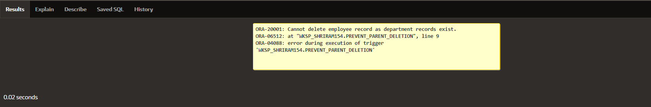

**Write a code in PL/SQL to create a trigger that checks for duplicate values in a specific column and raises an exception if found.**

**CREATE OR REPLACE TRIGGER prevent_duplicate_manager_id BEFORE INSERT OR UPDATE ON employees**

# FOR EACH ROW DECLARE

**pl_count NUMBER; BEGIN**

# SELECT COUNT(*)

**INTO pl_count FROM employees**

**WHERE manager_id = :NEW.manager_id AND employee_id != :NEW.employee_id; IF pl_count > 0 THEN**

**RAISE_APPLICATION_ERROR(-20003, 'Duplicate manager_id found: ' ||**

**:NEW.manager_id); END IF;**

# END;

**INSERT INTO employees (employee_id, first_name, last_name, email, phone_number, hire_date, job_id, salary, commission_pct, manager_id, department_id)**

**VALUES (202, 'Jane', 'Smith', 'john006@gmail.com',7383922241,'11/9/2000','ST_CLERK',10000,0.15,400,80);**

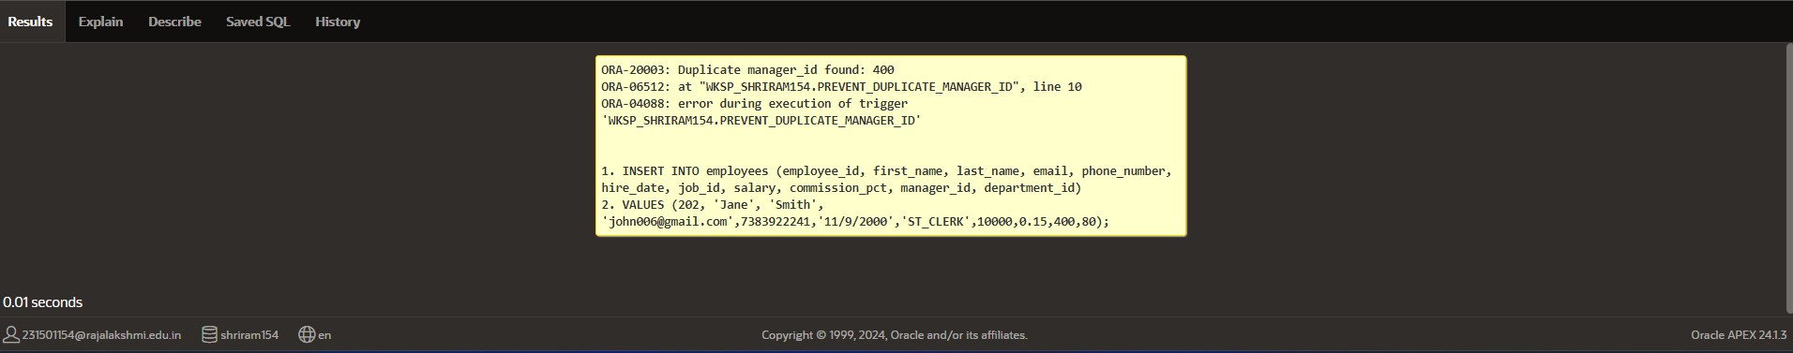

**Write a code in PL/SQL to create a trigger that restricts the insertion of new rows if the total of a**

**column's values exceeds a certain threshold.**

**CREATE OR REPLACE TRIGGER restrict_salary_insertion BEFORE INSERT ON employees**

# FOR EACH ROW DECLARE

**total_salary NUMBER; threshold NUMBER := 100000;**

# BEGIN

**SELECT SUM(salary) INTO total_salary FROM employees;**

**IF (total_salary + :NEW.salary) > threshold THEN**

**RAISE_APPLICATION_ERROR(-20004, 'Insertion denied: Total salary exceeds the threshold of ' || threshold);**

# END IF; END;

**INSERT INTO employees (employee_id, first_name, last_name, email, phone_number, hire_date, job_id, salary, commission_pct, manager_id, department_id)**

**VALUES (203, 'Charlie', 'Brown', 'charlie203@gmail.com', '9122334455','03/01/2021', '#cb203', 5000, 0.20, 1000, 50);**

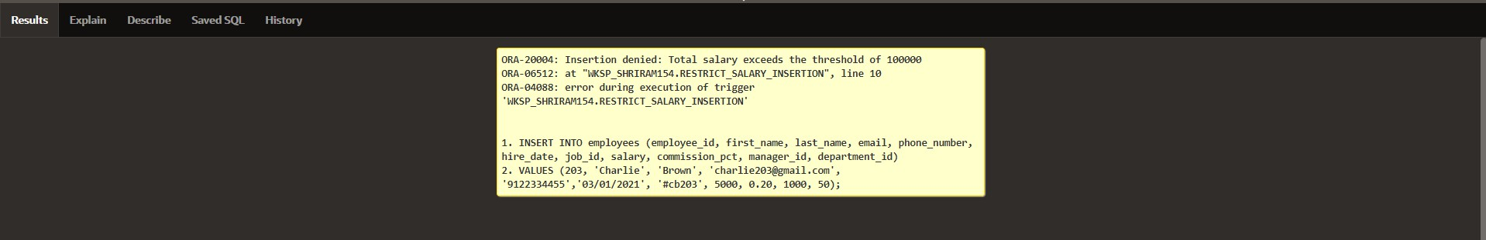

**Write a code in PL/SQL to design a trigger that captures changes made to specific columns and logs them in an audit table.**

**CREATE OR REPLACE TRIGGER audit_changes AFTER UPDATE OF salary, job_id ON employees FOR EACH ROW**

# BEGIN

**IF :OLD.salary != :NEW.salary OR :OLD.job_id != :NEW.job_id THEN INSERT INTO employee_audit (**

**employee_id, old_salary, new_salary, old_job_title, new_job_title, change_timestamp, changed_by**

# ) VALUES (

**:OLD.employee_id,**

**:OLD.salary,**

**:NEW.salary,**

**:OLD.job_id,**

**:NEW.job_id, SYSTIMESTAMP, USER**

# ); END IF;

**END;**

**UPDATE employees**

**SET salary = 55000, job_id = 'ST_CLERK' WHERE employee_id = 176;**

**SELECT * FROM employee_audit;**

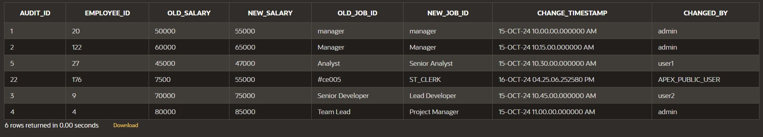

**Write a code in PL/SQL to implement a trigger that records user activity (inserts, updates, deletes) in an audit log for a given set of tables.**

**CREATE OR REPLACE TRIGGER trg_audit_employees AFTER INSERT OR UPDATE OR DELETE ON employees FOR EACH ROW**

# DECLARE

**v_old_values CLOB; v_new_values CLOB;**

# BEGIN

**IF INSERTING THEN**

**v_old_values := NULL;**

**v_new_values := 'employee_id: ' || :NEW.employee_id || ', ' || 'first_name: ' || :NEW.first_name || ', ' ||**

**'salary: ' || :NEW.salary;**

**INSERT INTO audit_log (action, table_name, record_id, changed_by, new_values) VALUES ('INSERT', 'employees', :NEW.employee_id, USER, v_new_values);**

# ELSIF UPDATING THEN

**v_old_values := 'employee_id: ' || :OLD.employee_id || ', ' || 'first_name: ' || :OLD.first_name || ', ' ||**

**'salary: ' || :OLD.salary;**

**v_new_values := 'employee_id: ' || :NEW.employee_id || ', ' || 'first_name: ' || :NEW.first_name || ', ' ||**

**'salary: ' || :NEW.salary;**

**INSERT INTO audit_log (action, table_name, record_id, changed_by, old_values, new_values)**

**VALUES ('UPDATE', 'employees', :NEW.employee_id, USER, v_old_values, v_new_values);**

# ELSIF DELETING THEN

**v_old_values := 'employee_id: ' || :OLD.employee_id || ', ' || 'first_name: ' || :OLD.first_name || ', ' ||**

**'salary: ' || :OLD.salary; v_new_values := NULL;**

**INSERT INTO audit_log (action, table_name, record_id, changed_by, old_values) VALUES ('DELETE', 'employees', :OLD.employee_id, USER, v_old_values);**

# END IF;

**INSERT INTO employees (employee_id, first_name, salary) VALUES (3, 'Ball', 50000);**

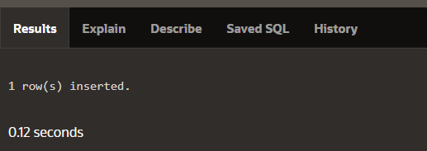

**UPDATE employees SET salary = 55000**

**WHERE employee_id = 3;**

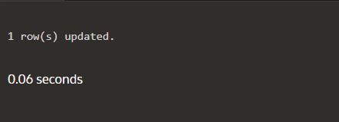

**DELETE FROM employees WHERE employee_id = 3;**

**SELECT * FROM audit_log;**

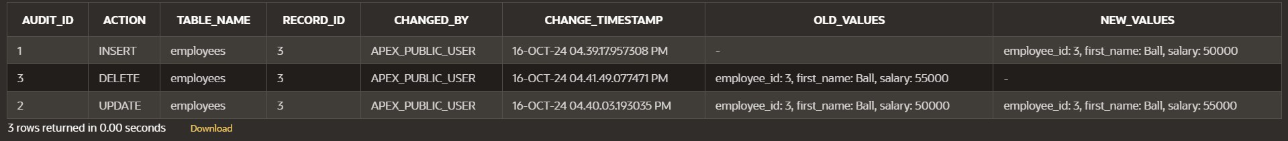

**Write a code in PL/SQL to implement a trigger that automatically calculates and updates a running total column for a table whenever new rows are inserted.**

**CREATE TABLE transactions ( transaction_id NUMBER PRIMARY KEY, amount NUMBER,**

**running_total NUMBER**

**);**

**CREATE OR REPLACE TRIGGER update_running_total FOR INSERT ON transactions**

# COMPOUND TRIGGER

**TYPE amount_array IS TABLE OF NUMBER INDEX BY PLS_INTEGER;**

**new_amounts amount_array;**

# BEFORE EACH ROW IS BEGIN

**new_amounts(:NEW.transaction_id) := :NEW.amount; END BEFORE EACH ROW;**

# AFTER STATEMENT IS BEGIN

**DECLARE**

**v_total NUMBER; BEGIN**

**SELECT NVL(MAX(running_total), 0) INTO v_total**

**FROM transactions;**

**FOR i IN new_amounts.FIRST .. new_amounts.LAST LOOP v_total := v_total + new_amounts(i);**

**UPDATE transactions**

**SET running_total = v_total WHERE transaction_id = i;**

# END LOOP; END;

**END AFTER STATEMENT;**

**END update_running_total;**

**INSERT INTO transactions (transaction_id, amount) VALUES (1, 10000);**

**INSERT INTO transactions (transaction_id, amount) VALUES (2, 20000);**

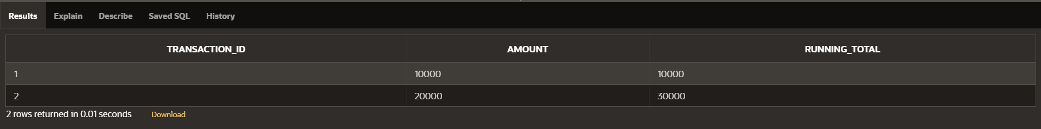

**Program 7**

**Write a code in PL/SQL to create a trigger that validates the availability of items before allowing an order to be placed, considering stock levels and pending orders.**

**CREATE TABLE inventory ( item_id NUMBER PRIMARY KEY,**

**item_name VARCHAR2(100), stock_level NUMBER**

**);**

**CREATE TABLE orders (**

**order_id NUMBER PRIMARY KEY, item_id NUMBER,**

**quantity NUMBER, order_status VARCHAR2(20),**

**CONSTRAINT fk_item FOREIGN KEY (item_id) REFERENCES inventory(item_id)**

**);**

**CREATE OR REPLACE TRIGGER validate_stock_before_order BEFORE INSERT ON orders**

# FOR EACH ROW DECLARE

**v_stock_level NUMBER; v_pending_orders NUMBER;**

# BEGIN

**SELECT stock_level INTO v_stock_level FROM inventory**

**WHERE item_id = :NEW.item_id; SELECT NVL(SUM(quantity), 0) INTO v_pending_orders**

**FROM orders**

**WHERE item_id = :NEW.item_id AND order_status = 'Pending';**

**IF (:NEW.quantity + v_pending_orders) > v_stock_level THEN RAISE_APPLICATION_ERROR(-20001, 'Insufficient stock for item: ' || :NEW.item_id);**

# END IF; END;

**INSERT INTO orders (order_id, item_id, quantity, order_status) VALUES (1, 101, 5, 'Pending');**

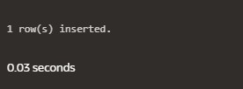

**INSERT INTO orders (order_id, item_id, quantity, order_status) VALUES (2, 103, 20, 'Pending');**

